**INF10025 Data Management and Analytics**

# Task 3 – Pass Submission

Student Number: 104071453  
Student Name: Marco Giacoppo

### Pass 3a

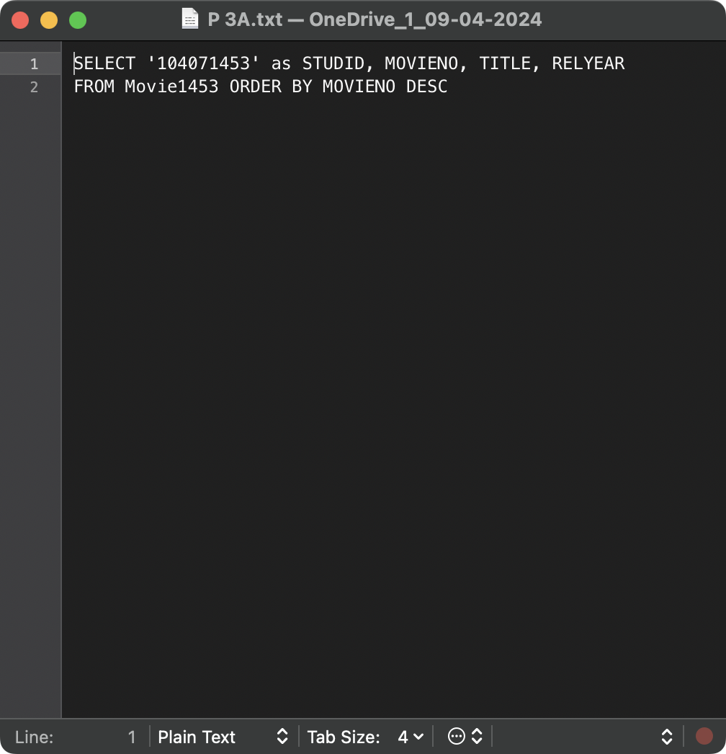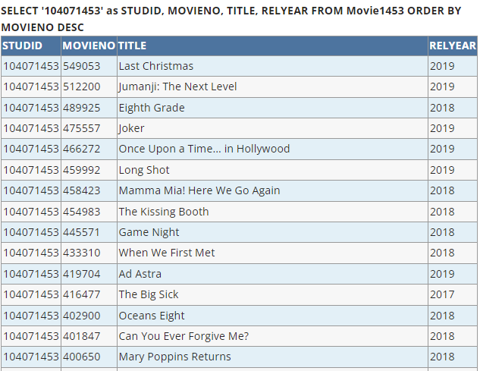

### Pass 3b

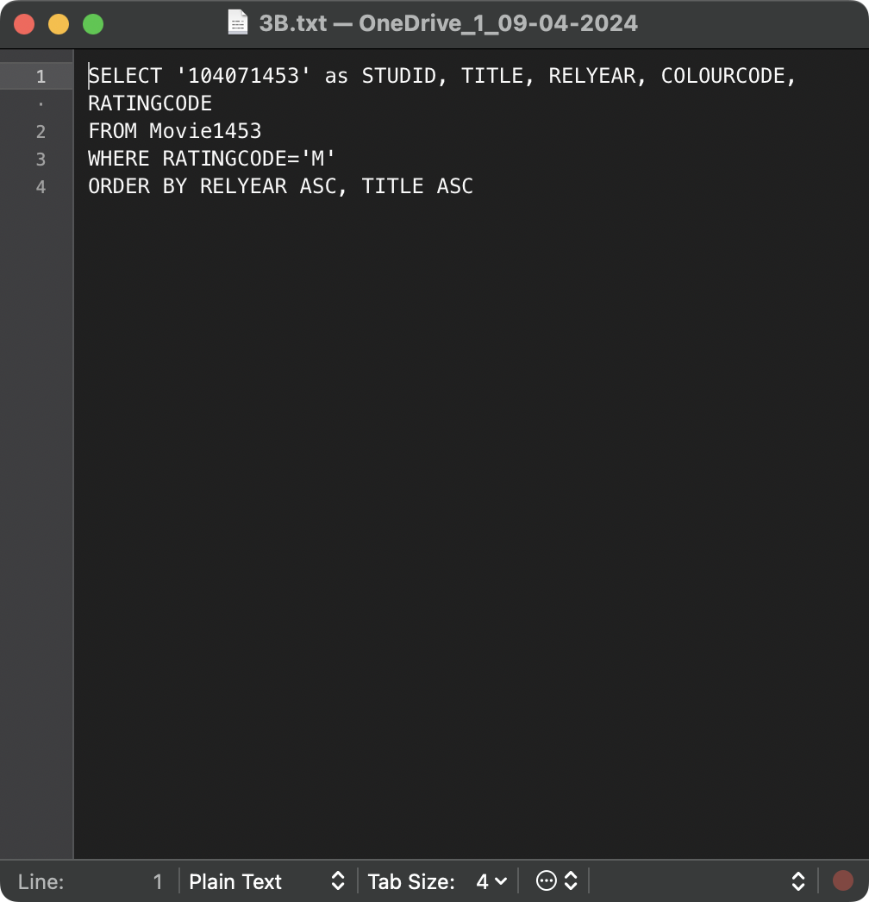

### Pass 3c

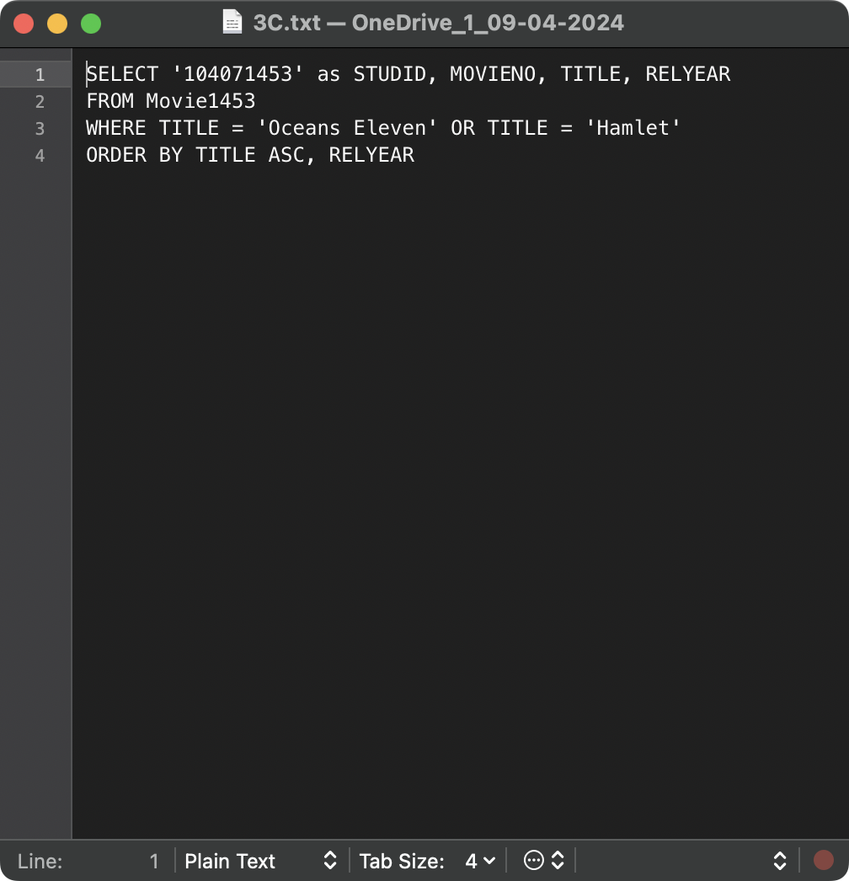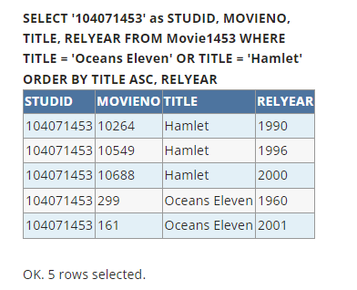

### Pass 3d

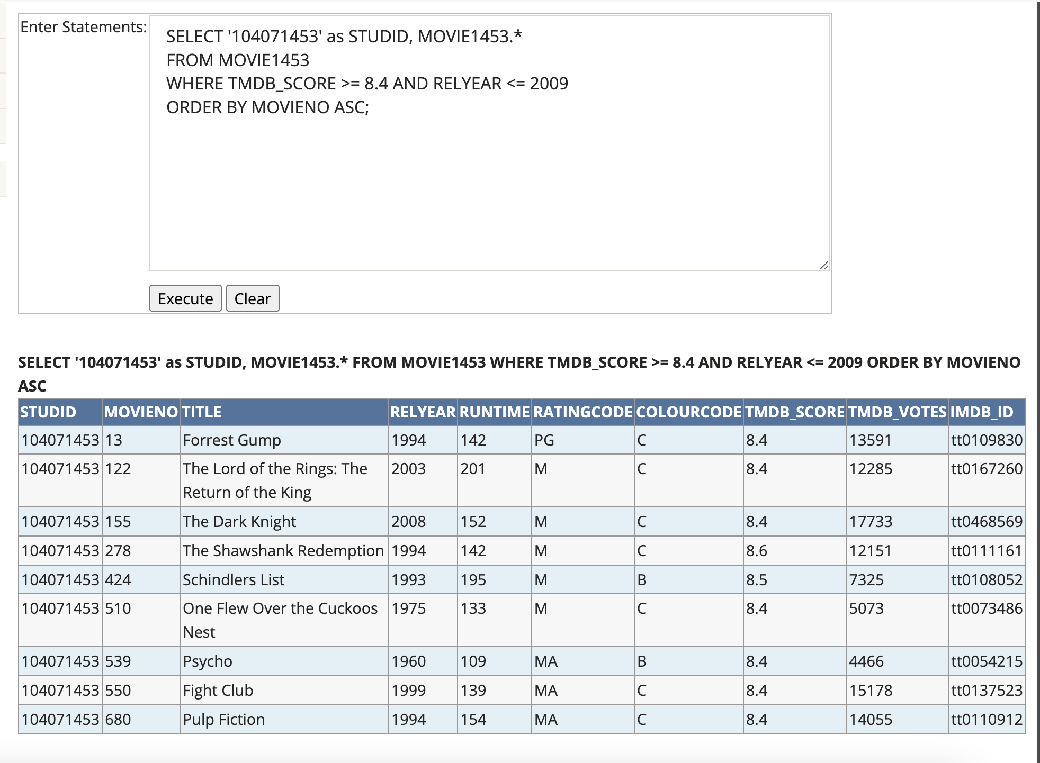

### Pass 3e

### Pass 3f

### Pass 3g

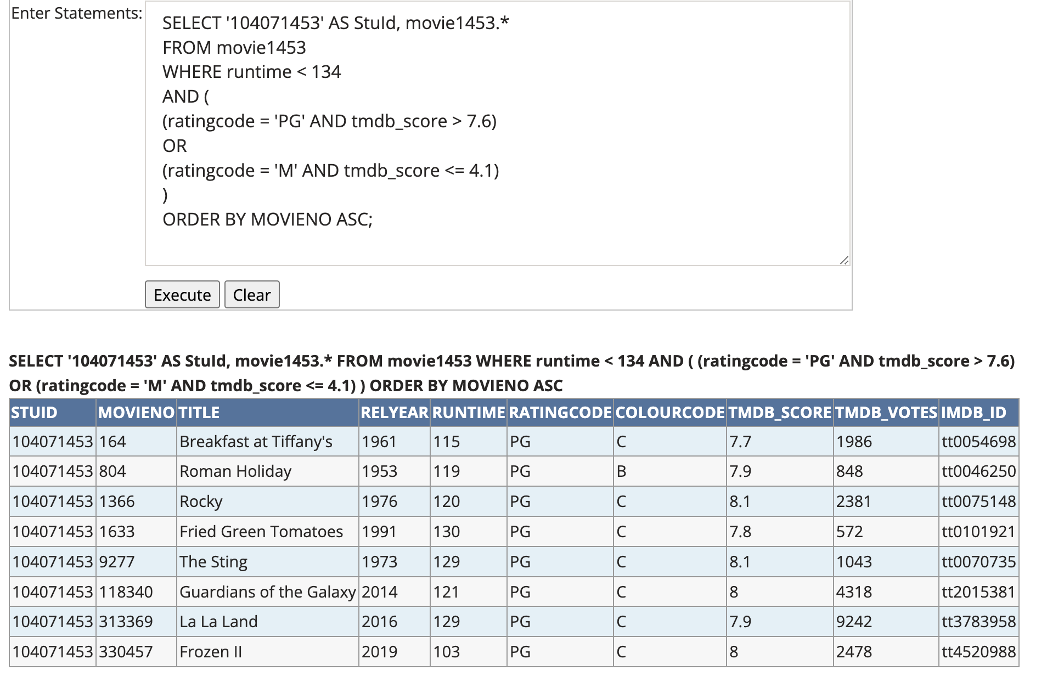

### Pass 3h

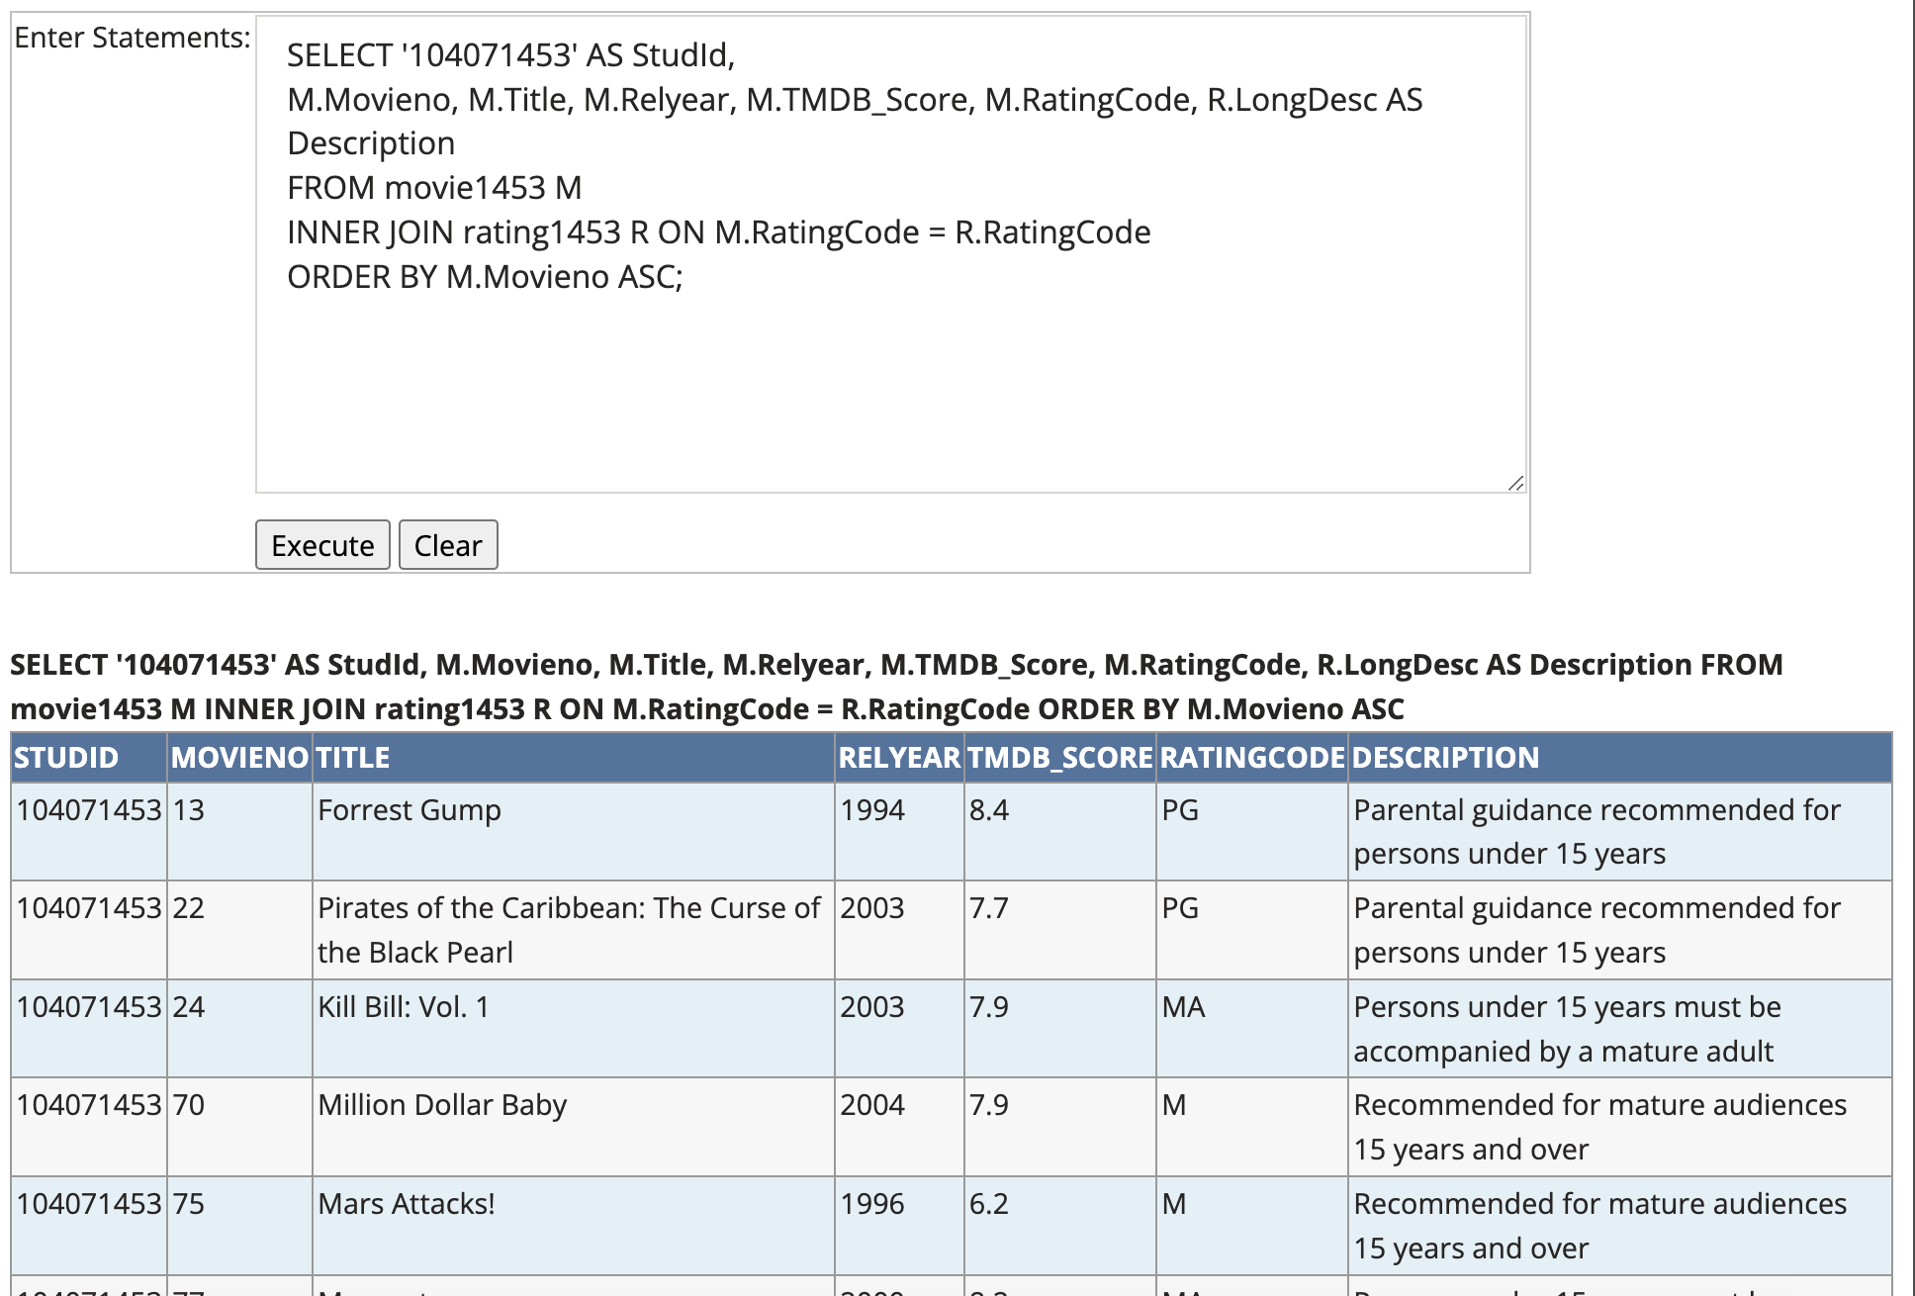

### Pass 3i

